**DM2295 – Game Development Project**

**User Guide**

**Team Number:** 13

**Members:** Shum Weng Sang(Leader)

Leow Wei Thou, Samuel

Chung Wei Qi

Chiu Ying Tzu

Amos Lee Jia Shen

**Game Title:** Haze Outlet

**Genre:** 2.5D – Simulation

# Game Objective

The objective of this game is to sell the mask as many as the player can when the waves of haze come.

**Gameplay:**

At the beginning, the player starts with a sum of money and 3 stores. The player chooses the amount of gas masks to purchase, before assigning them to whichever stores at chosen prices. The day will start after confirmation of stock placement, counting down the day and simulating a situation where the haze is drifting into Singapore.

At the start of each day, the player gets to replenish their stock, and reassign prices and amounts to the store of their choice. The player also gets to move their stores on the map to how they see fit, depending on the sometimes in-accurate weather forecast or the dynamic haze movements.

The game ends after 7 in- game days, where the PSI readings will reach up to even 500 PSI. Success or failure will be determined if the player has earned a profit or loss.

# Controls

Mouse (Left Click, Right Click, Mouse Wheel)

Keyboard (W, A, S, D, Esc Keys)

**Mouse Controls:**

Pressing the left mouse button on the buttons on the number buttons allow you to buy mask and make decision to the number of mask and price for sale, you can also click on the shop to check the detail information of each shops.

Pressing the right mouse button able to deselect the shop if you have selected any.

Press and hold down the right mouse button allow you to rotate the camera to view the shops and buyers in different angle.

Rolling the mouse wheel allow you to zoom in and out the views in the game.

**Keyboard controls:**

Pressing the ‘W’ ‘S’ ‘A’ ‘D’ allow you to move the camera forward, backward, left and right, ‘Esc’ allow your to quit the game anytime but without saving the game progress.

# Game Mechanics/Gameplay Elements

**Tile-based grid map:**

Our game uses a tile-based grid system as the core mechanic. The player is capable of moving the shops into grids as where he likes.

**Tile Types:**

## Tile texture

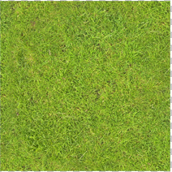

***The three shops***

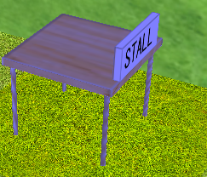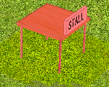 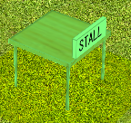

Shop 1 – Blue, Shop2 – Red, Shop3 – Green.

**Buttons:**

***Menu***

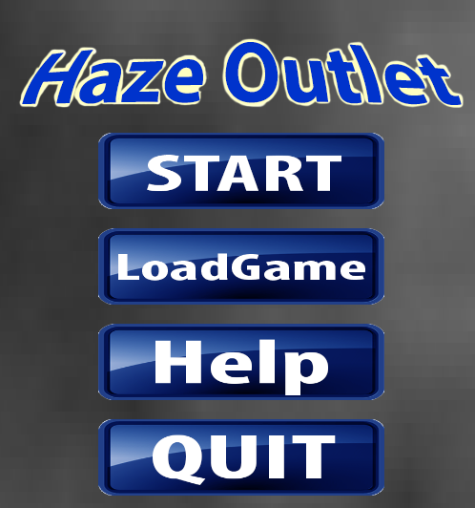

START – start the game.

Load Game – load the game progress you have saved before.

Help – Go to help page.

Quit – exit the game.

***In game:***

  

Number of mask you can buy and to decide how many for sale in each shop.

  

Price of each mask you can set for sale.

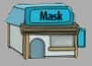 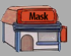 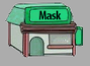

Three shop icons use for set numer of mask and price for sale. Also check the information of each shop.



Pause the game.



Close shop information.



Reset the setting for the shops.



Back to previous page.

**Currency:**



The currency is used by the player to buy masks, player can earn more money by selling the mask. At the end of every day, the amount of money you have earned in each shop will be show and add to your current money.

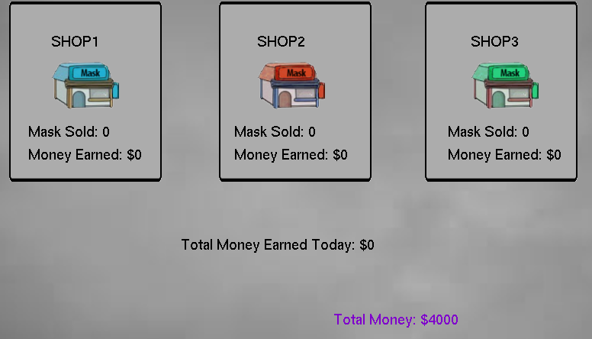

**Mask:**

You are able to buy the mask at the start of every day and game play.

Carefully decide how many mask you going to sell in each shop. The mask will ***not*** be return at the end of the day.

**Score:**

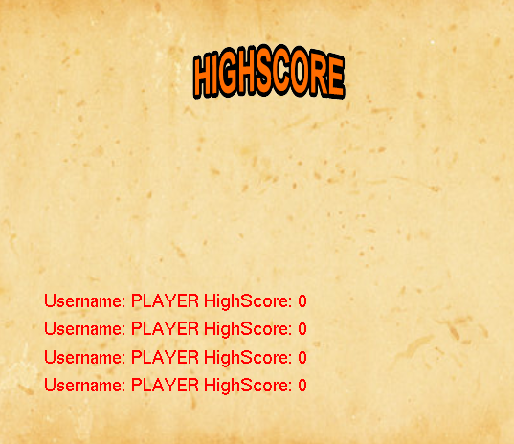

The score system is a way for the player to keep track of his high-score, score can be earned by selling more mask and earn more many, At the end of the 7th day, the remain money you have is the score.